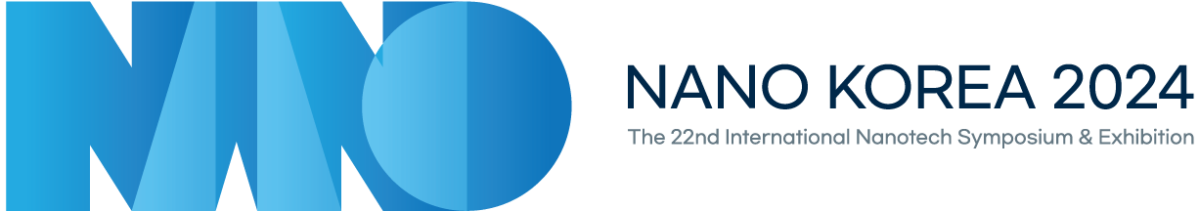

**Sponsorship Application Form**

|  |  |  |  |  |
| --- | --- | --- | --- | --- |
| **Company Information** | **Company Name** |  | **Country** |  |
| **Homepage** |  | **Zip Code** |  |
| **Address** |  | | |
| **Person in Charge**  **Name** |  | **Department**  **/Position** |  |
| **E-mail** |  | **Contact Number** | + |
| **Sponsorship** | **Official**  **Sponsorship** | □ Platinum Sponsor | | KRW 20,000,000 |
| □ Gold Sponsor | | KRW 10,000,000 |
| □ Silver Sponsor | | KRW 5,000,000 |
| □ Bronze Sponsor | | KRW 3,000,000 |
| **Individual Sponsorship Options** | □ Advertisement in Program Book | | KRW 1,500,000 |
| □ VIP Lounge | | KRW 3,000,000 |
| □ Promotional Materials | | KRW 10,000,000 |
| □ Video Advertisement | | KRW 20,000,000 |
| **Total Amount** | | | **KRW** |

**▣ Account Information**

Account Holder : Korea Nanotechnology Research Society(KoNTRS)

Swift Code : HVBKKRSEXXX  
Account Number : 1005-303-820390

Bank Name: WOORI BANK  
Bank Branch Address: 1585, Sangam-dong, Mapo-gu, Seoul, Korea

**Date : Name :** (Signature)

|  |
| --- |
| **NANO KOREA 2024 Symposium Secretariat**  3F, 14, Nambusunhwan-ro 354-gil, Seocho-gu, Seoul, 06737, Korea  Tel: +82-42-472-7458 | Fax: +82-42-472-7459 | E-mail: [symposium@kontrs.or.kr](mailto:symposium@kontrs.or.kr) |